WHY QING DYNASTY DIED IN CHINA
Institutional affiliations.
Student name.
date

WHY QING DYNASTY DIED IN CHINA

China being a cosmopolitan country is a nation with a variety of different culture. Footbinding can be traced as back as the 13th century. During the Han dynasty, small feet for women was highly considered for beauty and dancing around the QING'S premises. This information was first documented from the court of the Southern Tang dynasty in Nanjing, which celebrated the fame of its dancing girls renowned for their tiny feet and beautiful bow shoes. The practice became the standard for feminine beauty in the imperial court, spreading downward socially and geographically as the lower classes strove to imitate the style of the elite.
In its most fashionable form, footbinding was the act of wrapping a three-five-year old girl's feet with binding to bend the toes under, break the bones and force the back of the foot together. Its purpose was to produce a tiny foot, the golden lotus' which was three inches long and thought to be both lovely and alluring. Its believed that the origin of footbinding emerged in the Southern Tang dynasty around 920 A.D., WHERE THE EMPEROR Li Yu ordered his favorite concubine Fragrant girl, to bind her feet with silk bands and dance on a golden lotus platform encrusted with pearls and gems. After that, women inside and outside the court began taking up strips of cloth and binding their feet, thinking them beautiful and distinguished, dainty and elegant. It gradually became the prevailing style, and golden lotus became a synonym for bound feet. However social groups like the Hakka in Southern China, women’s feet were generally not bound and even among the imperial courts of the Ming and Qing dynasties was not strictly observed.
Tianjin, a city on the east coast of North China, has the world's fourth-largest seaport.[1] It is one of the four centrally administered municipalities of China.[2] The urban population of Tianjin is 6,825,105, ranked the fourth largest among the cities in China. Our tale about this city and its river conservancy took place before the birth of its modern seaport. Across the last several decades of China's last imperial dynasty, the Qing (1644-1912), and China's first republic (1912-1949), on the banks of a river connecting Tianjin with the sea, the most important seaport of North China in the early twentieth century was built, thanks to the consistent efforts of river conservancy. In this story, we will see that Tianjin was not destined to become a seaport. To the contrary, Tianjin's status and prospect as a seaport were often questioned.[3] This story makes an inquiry into how Tianjin, facing challenges from other potential ports and doubts from various parties, avoided misfortune on the brink of ceasing to be a seaport and remained one until the mid-twentieth century.
Located 70 miles to the southeast of Beijing and 30 miles west offshore, the city of Tianjin began to form as a military fortress in the thirteenth century. The Northern Grand Canal, Southern Grand Canal, and three rivers merged into the Hai River (or Haihe, meaning “the river of the sea” in Chinese) at Tianjin and flowed into the Bohai Sea at the Gulf of Zhili (see figure 1 and figure 2). Once the Ming emperor Zhu Di moved his capital from Nanjing to Beijing in 1420, to secure the supplies to this new capital, he ordered the dredging of the Grand Canal, the transport artery of the southern and northern reaches of the empire. Tianjin thus became the last stop of the long-distance tribute grain transport on the Grand Canal before the tribute grain could reach the capital. [4] Gradually turning into a bustling Grand Canal port, Tianjin attracted merchants who brought from the south sugar, paper, silk, porcelains, and herbs, trading for dates, pears, cotton, fur, and peanuts produced from Tianjin's broad hinterland. Tianjin was also the biggest salt production center of North China. Numerous saltpans spread along the seashore, producing one-eighth of the total amount of salt produced in China. The circulation of all kinds of goods, especially the monopolized salt trade,[5] nurtured many wealthy merchants in Tianjin. They built gorgeous residential compounds and gardens, and sponsored charitable organizations, schools, and theaters. Tianjin thus prospered as a Grand Canal port and grew into a commercial city with a thriving urban culture. Starting in the 1850s, the Grand Canal was severely silted up in its sections to the north of the Yangtze River and was frequently deprived of traffic due to local disturbances. As a result, many formerly vibrant ports of the Grand Canal began to decline. Would Tianjin be one of them?
When transportation on the Grand Canal became unreliable, Tianjin had to reposition itself in the transport system to keep its prosperity. In the 1850s, steamships were introduced to China and coastal trade, and sea transport grew. While being a Grand Canal port, Tianjin was also a destination for boats sailing from Fujian Province and Guangdong Province along the coast. Could Tianjin turn to the sea? The Bohai Sea is thirty miles to the east of Tianjin and was connected with Tianjin by a shallow and sinuous river, the Haihe.[6] The Haihe had been used occasionally to move tribute grain and other goods whenever the transportation on the Grand Canal was impeded, but it was not an ideal river for developing steamer transportation. Nor was the Qing government willing to allow steamship transportation at Tianjin. Having been forced into several unequal treaties by the foreign gunboats approaching China’s coast from the sea, the Qing government feared that a steamer terminal so close to Beijing would put the court in danger. However, once the Anglo-French allied forces defeated the Qing troops during the Second Opium War (1856-1860), whether to open Tianjin to foreign steamers and trade was no longer a decision that the Qing government could make on its own. After a series of battles at the Dagu Fort, on the coast near Tianjin, the foreign forces made their way through Tianjin and attacked Beijing. The emperor escaped from his palace and agreed to sign the so-called "Treaty of Peking" with Britain, France, and Russia. The treaty opened Tianjin as a treaty port, ceded lands to Britain and Russia, and allowed Western Christian groups to rent or purchase property for their establishments.
Before Tianjin, fifteen ports including Guangzhou, Fuzhou, Shanghai, and Nanjing had been opened as “treaty ports” to foreign trade and residence as a result of the Western imperialist powers’ forces and unequal treaties.[7] The provisions of the Treaty of Peking further granted the Western powers the privilege of renting land permanently in the treaty ports to establish their "concessions" which they administered independently and where they enjoyed the consular jurisdiction. As soon as Tianjin became a treaty port, Britain, France, and the United States selected their parcels of land to the southeast of the Chinese walled city, along with the west bank of the Haihe. Altogether these three powers occupied an area of 4,058 square meters, extending two miles along the waterfront. Later, the number of concessions in Tianjin grew to nine: Germany obtained its authorization in 1895, then Japan in 1898, Russia in 1900, and Italy, Austro-Hungary, and Belgium in 1902.[8] These concessions covered 15 square kilometers and were all located along the two banks of the Haihe (see figure 3). Not until 1947 had the last three remaining concessions been returned to the Chinese government.
With their interests concentrating on the Haihe and their decades' efforts of building the concessions at stake, the different municipalities of the settlements strived to keep the seaport alive. To compete with railroad and Tanggu, they had to tackle the chronic problem: the bad navigating conditions of the Haihe. The municipalities sought help from the subtle bodies who then pressured the Qing government to cooperate in the Haihe conservancy. A Sino-foreign jointly administered river institution, the Haihe Conservancy Commission, was established in 1897. The obligation of the Qing government in providing funds for this commission was written down in the protocol signed between China and the eight allied forces after the Boxer Uprising (1899-1901).[25]
Since 1897, the Haihe Conservancy Commission had constantly worked on various projects on Haihe. Five of the most difficult sections of the Haihe for steamers to pass were straightened over the years from 1901 to 1923. Numerous bends where the radius was too small were cut off, and the river course was carefully trained and deepened. These "cutting" projects shortened the navigating distance from the sea to Tianjin by 17 miles (see figure 5). Before the cuttings were made, it took a sea-going steamer seven to eight hours to navigate from Dagu to Tianjin. As the river course was straightened and deepened, the time was reduced to five hours 10 minutes in 1903 and four hours 10 minutes in 1904. In 1904, when three significant cuttings had been completed, the fastest record of navigating from Dagu to Tianjin was 3.75 hours.[26] A straighter and deeper river course was not enough to make Tianjin a good seaport. At the mouth of the Haihe, a strip of sandbar lying underneath the water, the so-called Dagu Bar, obstructing large steamers from entering the Haihe. In 1905, the Commission brought up a plan of dredging a 6-foot-deep channel across the Dagu Bar, so that on an 8-foot tide, ships drawing 12 feet could pass into the Haihe.[27] The Commission achieved the goal of a 6-foot channel on the crest of the bar in April 1915.[28] To keep Tianjin open to steamers, the Haihe had been engineered into an artificial canal. Even more important in the Commission’s job was the maintenance work. The Commission bought icebreakers to keep the port on the Haihe open all year long, as well as dredgers to clear sediment deposited on the riverbed and at the Dagu Bar. Lighthouses, docks, and conduits and other infrastructure that a seaport needed were also built and maintained. To provide data for conservancy works and to archive the performance of the river, the Commission took surveys of the river and recorded the water level, height of the tide, and volume of sediment regularly. Fortunately, these expensive and challenging works paid off immediately. The number of steamers that could come through the Haihe all the way to the concessions in Tianjin significantly increased. In 1905 when three cuttings had been done, 395 ships arrived at the piers of the foreign settlements. The figure was 333 in 1903 and 374 in 1904. The number rose to 511 in 1908 and 623 in 1909. From 1909 to 1916, each year over 600 steamers arrived at the port of Tianjin. In 1914 and 1915, the numbers even reached 814 and 768. [29] The value of trade of Tianjin also rapidly grew from 1894’s 44,277,054 Taels to 1914’s 123,639,776 Taels.[30]
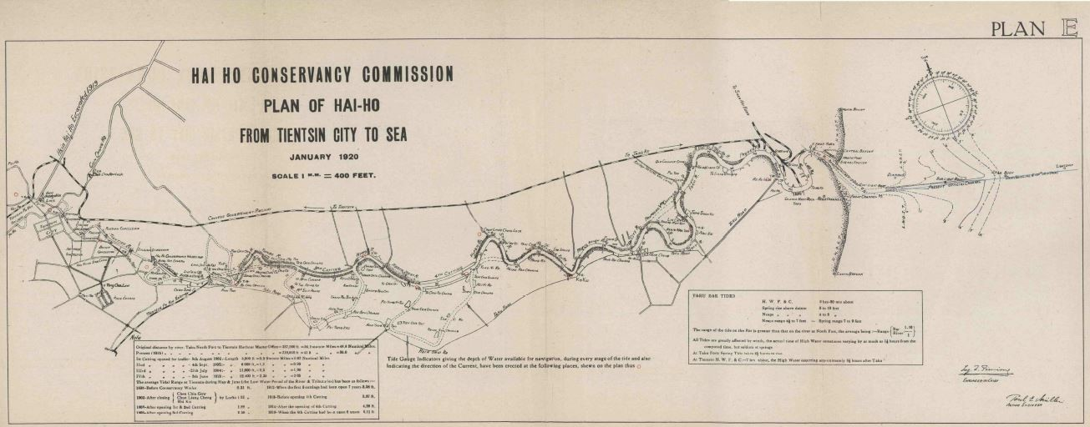
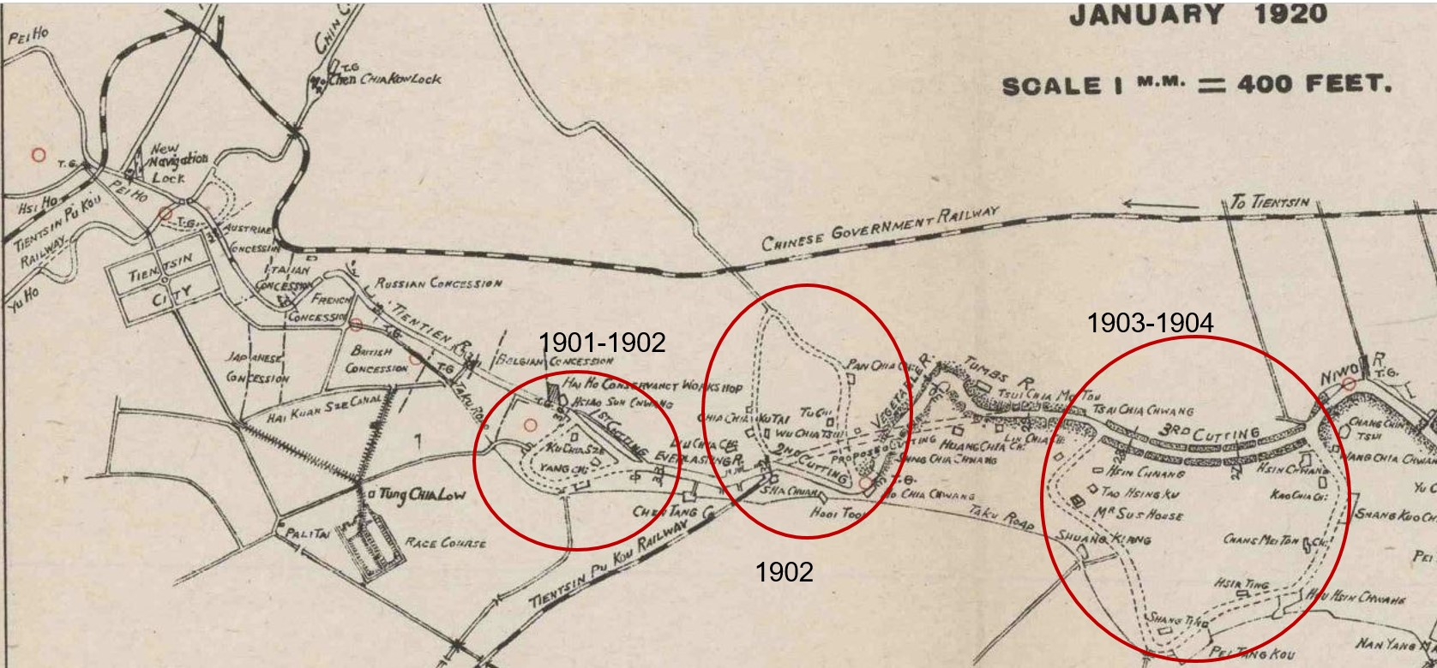
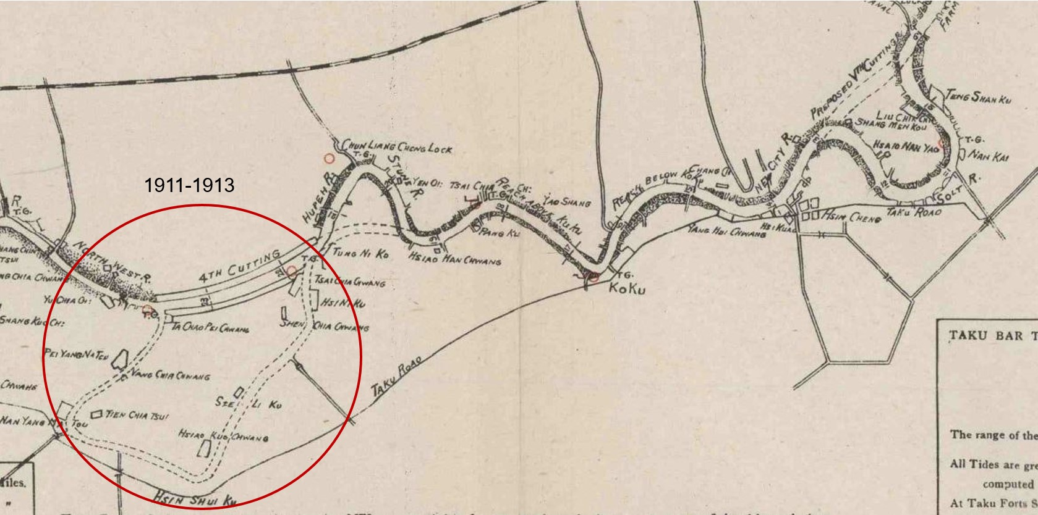
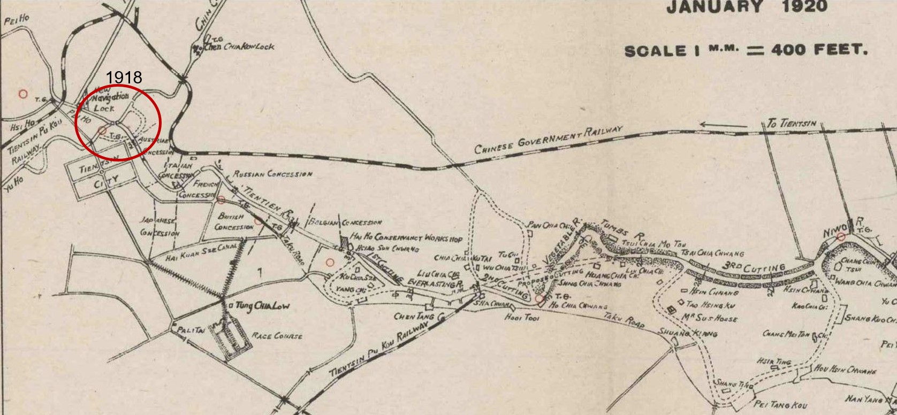
Figure 5 (a,b,c,d stacked): The “cuttings” on the Haihe (areas highlighted by author). The Haihe Conservancy Commission conducted four “cuttings” on the Haihe from 1901-1913. The fifth cutting in 1918 was designed by the Commission and was carried out by the local gentry.
Although Tanggu had better natural conditions that a seaport required and had already been facilitated into a small dock by the end of the nineteenth century, the idea of moving the port to Tanggu was not carried out. Tanggu as an alternative port was not chosen in the 1890s, but the possibility of running the primary port of Tianjin to Tanggu never died out. Despite the tireless efforts of the Conservancy of Haihe, in the 1910s, the Haihe was again silted up, and Tianjin's potential of continuous thriving was questioned again.
Conclusion
That Tianjin could transform into a seaport after the decline of the Grand Canal and could remain a seaport until the mid-twentieth century was primarily due to the specific socio-political situation and the river conservancy projects. The existing narratives on the development of Tianjin in the late nineteenth and early twentieth centuries often attribute Tianjin's successful transition from a Grand Canal port to the most significant North China seaport to its natural geography, as if Tianjin could quickly turn to the sea when the Grand Canal declined given its proximity to the sea. Our story shows that it was not an easy and natural choice to build a seaport in Tianjin. Tianjin had two options in the 1880s. One option was to keep Tianjin open to steamer traffic by entirely rechanneling and continuously maintaining the Haihe; the other option was to facilitate the coastal village Tanggu as the terminal for steamers and relocate a business there or expand the city significantly. With multiple foreign powers settling and investing on the banks of the Haihe, the first option was chosen. If it were not for the constant engineering works and maintenance on the Haihe and its upper streams, Tianjin would not have been able to develop into a high-capacity seaport and remain one for half a century. However, our story further shows that, although Tianjin’s water landscape had been completely transformed to make it accessible to steamers, the effects of these projects did not usually last and whether Tianjin should and could be kept as a seaport was often questioned. Connected with the sea by an artificial river, Tianjin’s status as a seaport was heavily dependent on the continuous conservancy efforts on the Haihe and its tributaries. The episode in 1915 demonstrates how fragile this system of maintaining the port of Tianjin was. Any disruptive project such as 1915 plan to give the Northern Grand Canal a new course could end Tianjin's lifespan as a seaport. And yet, this delicate system operated for more than forty years. Why? The answer is the complicated political situation of Tianjin. At various times, as many as nine Western powers coexisted in Tianjin starting in 1860. The Qing Dynasty collapsed in 1912 and the leadership of the next regime, the Republic of China, changed hands several times. None of these powers had complete control of Tianjin and were able to convince or coerce the vested interests to give up the port in Tianjin and implement the enormous project of building a new port from scratch. In 1937, as soon as the Japanese troops took over Tianjin and eliminated the other powers, they immediately began expanding and facilitating the port of Tanggu. After taking a lengthy detour for nearly forty years, the trajectory of Tianjin's development came back to the path that had been discarded earlier. Only after examining the episodes in which Tianjin's role as a seaport was not taken for granted but was questioned, can we reconsider Tianjin's trajectory to modernization, not as a linear and smooth process but full of twists and turns. The episodes here in which Tianjin reversed its destiny several times represent the resilience and dynamism that the river generated in urban development. The Haihe was in a web of waters, extending far beyond Tianjin. The network of waters wove a vast region of North China together physically and socially. The Haihe empowered all the parties who had control of any section of the river and its tributaries to project influence by river works on other regions in this web. Thus, the interests of the provinces and various powers in control were all interdependent. The Haihe also provided a space for the segmented administrations of Tianjin and its vicinity to negotiate and mediate their conflicting agendas. To successfully implement a river conservancy project, the parties that would be affected had to reach an OPEN RIVERS: ISSUE EIGHT: FALL 2017 / FEATURE 82 ISSUE EIGHT: FALL 2017 point of agreement. Behind the river, conservancy projects were often intertwined agendas. Even if the foreigners had treaty-granted privileges in operating their concessions and intervening in the policy-making of the Chinese government, when proposing a river conservancy project, they had to deliver not only their commercial interests in Tianjin but also the significant concerns of the Chinese—the flood relief—in a larger area. The success of the seaport of Tianjin in the early twentieth century was forged by the checks and balances that were created in the conservancy issues among the various powers, Chinese and foreign, central and local.

http://editions.lib.umn.edu/openrivers/article/river-conservancy-and-the-undetermined-future-of-the-port-of-tianjin/
http://editions.lib.umn.edu/openrivers/wp-content/uploads/sites/9/2017/11/6_kan_feature_fall17.pdf

